Eg: Exceptional_Handling_Eg24

// go through the code

Eg: Exceptional_Handling_Eg25

// go through the code

Eg: Exceptionsl_Handling_Eg26

// go through the code

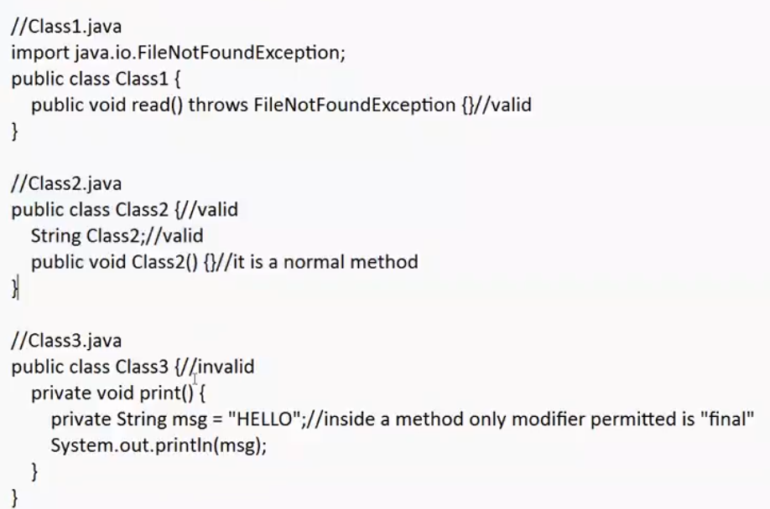

Whenever using throws compiler will not check for the logic in the try block. Even it is a fully checked exception , compiler will not check whether there is a logic that gives exception.

Eg: Exception_Handling_Eg27

// go through the code

Eg: Exception_handling_Eg28

// go through the code